

FACULTY OF TECHNOLOGY AND ENGINEERING
DEVANG PATEL INSTITUTE OF ADVANCE TECHNOLOGY
AND RESEARCH

DEPARTMENT OF COMPUTER ENGINEERING

A.Y 2026 – 27 Semester – 3

LAB MANUAL

CSUC201 Fundamentals of Data Structures and Algorithms


Practical 6: Stack Implementation using Array and Linked List, with Expression Processing
Practical Aim
To implement stack using array and linked list, and apply stack-based logic to expression conversion, evaluation, and bracket validation problems.
Problem 1
A cafeteria stacks clean trays on a fixed-size counter. New trays are always placed on top, and customers always take from the top. The counter can hold at most n trays at a time — if it is full, no more trays can be added, and if it is empty, no tray can be taken. Given a sequence of place and take operations, implement this fixed-capacity tray stack and print the current top tray after each operation. Report an error if a place or take operation cannot be performed.
Describe how your solution tracks whether the stack is full or empty. What are the exact conditions you check before a push and before a pop, and what does your program do when those conditions fail?
Theory:
1. A circular array is one way to reuse freed slots without shifting all elements. Without implementing it, explain what change would need to be made to your front and rear pointer logic to make the array behave circularly, and what new condition would indicate a full array.
A circular array queue reuses empty positions by moving the front and rear pointers back to the beginning when they reach the end of the array. This can be done using the modulo operator, such as (rear + 1) % size. In a circular queue that reserves one slot to distinguish full from empty, the queue is full when (rear + 1) % size == front. Other implementations can use a separate count variable to track the number of elements.

Code: https://github.com/kanan2007s-sys/FDSA_B/tree/main/Practical%201

Screenshot:
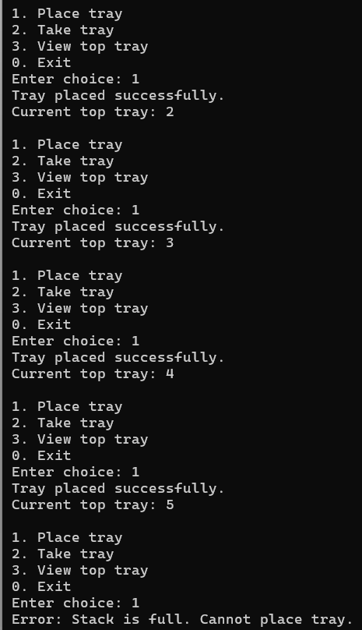
Description:
Implemented a fixed-capacity stack using an array.
Performed push and pop operations and displayed the top element.
Handled stack overflow and underflow conditions.

Challenge:
I didn’t face any major challenge since it was stack implementation with array.

Problem 2
A web browser keeps track of pages visited so that the back button always returns to the most recently visited page. Unlike a fixed counter, the browser has no hard limit on how many pages it can remember — it grows as the user visits more pages and shrinks as they press back. Given a sequence of visit and back operations, implement this unlimited page history and print the current page after each operation.
Describe how your solution differs from Problem 1 in how it handles memory. What happens in your solution when the user presses back on the very first page with no history left?
Theory:
2. Your linked list stack has no fixed capacity limit. But in practice, can it still run out of space? What determines the actual limit, and why is that limit invisible in your code?
Yes, a linked list stack can run out of memory if too many elements are added. Its actual capacity depends on the available system memory and the memory required by each node. The code does not define a fixed maximum size, but every new node still requires memory, and allocation may fail when resources are exhausted.
Code: https://github.com/kanan2007s-sys/FDSA_B/tree/main/Practical%201

Screenshot:
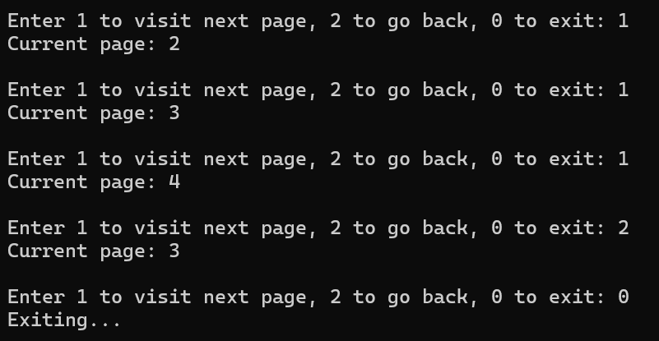

Description:
Implemented a dynamic stack using a linked list to manage browser history.
Performed visit and back operations and displayed the current page.
Handled cases where no previous page was available.

Challenge:
Since it was implementation of stack using linked list , so I faced challenge in pointer little bit.

Problem 3
A calculator application receives arithmetic expressions typed by users in the usual way —numbers and operators written in between, with brackets to control priority (e.g. 3 + 4 * 2 or (3 +4) * 2). Internally the calculator needs to convert each expression into a form where operatorsappear after their operands, so it can evaluate them without needing to re-read brackets. Givenan infix expression, convert it to the equivalent postfix form and print the result.
Theory:
3. operator precedence determines the order in which operators are placed into the output. Without tracing any expression, explain what would go wrong in your output if your solution treated all operators as having equal precedence.
If all operators are treated as having equal precedence, the postfix expression may not preserve the intended order of calculations. For example, multiplication and division should generally be performed before addition and subtraction. Ignoring precedence can produce an incorrect result because the converted expression may represent a different calculation from the original expression.
Code: https://github.com/kanan2007s-sys/FDSA_B/tree/main/Practical%201

Screenshot:
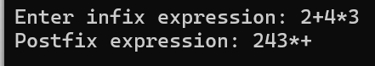

Description:
Implemented conversion of infix expressions into postfix expressions using a stack.
Used operator precedence and associativity to arrange operators correctly.
Handled brackets and remaining operators during conversion.

Challenge:
I faced challenge in implementing the concept of infex with the equation.

Conclusion: Successfully implemented stacks using arrays and linked lists and understood their use in expression conversion and last-in, first-out operations.

